**Tutorials and Progression**

When it comes to teaching the player the basic controls of the game, we will need to avoid the assumption that they have played one of the games listed in our ‘inspirations’ section or even a 3D platform game. The basics of movement and weapon usage we hope to convey in an implicit manner. This does run the risk of making the player unaware of some required skills, however, we will be implementing skill gates, locking the player’s progression until they understand a mechanic well enough to continue.

**The Sword:**

As the simplest weapon, the sword will be the starting weapon. Due to it having no special features other than granting the double jump, all we would need is a wall requiring a double jump to scale and some weak enemies to engage in combat. Signs with artwork showing how to perform each move will be included within the segments of the levels that require them.

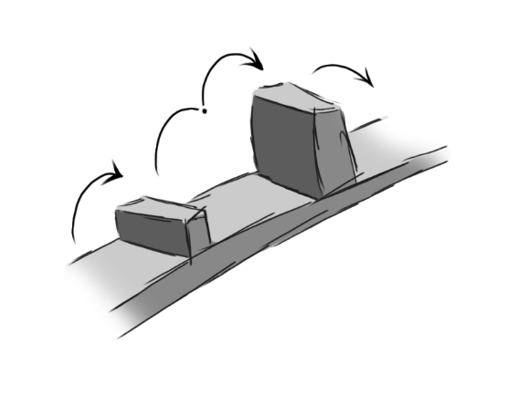

Figure - Double Jump Tutorial

**The Shield:**

The shield will be the first unlock. The shield charge and shockwave abilities both focus around knockback, so having enemies like the Domino on narrow paths and near ledges is a must. The shield slide will be harder to teach. Several slopes will be available to use the feature on, and at the end, a large slope requiring the player to get some speed to make a jump or race through a pit of proximity spike traps will be the skill gate for the shield slide ability.

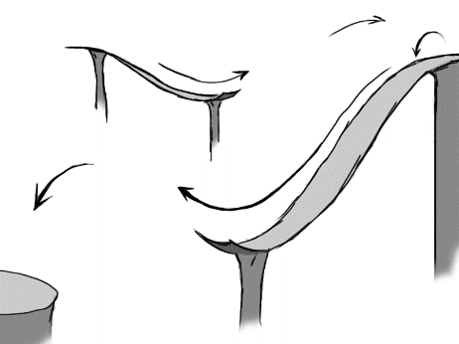

Figure - Shield Slide Tutorial

**The Scythe:**

The scythe is another simple weapon, so giving it as the third item is wise. Having the player collide with a zipline to progress will explain the special feature of the weapon. The wide hit arc, hitbox and life-steal will be shown through combat with swarms of weak enemies, like Lobuzz and Dizzy Chargers, and upon using the weapon like this, clear indications that it is affecting player health will be shown.

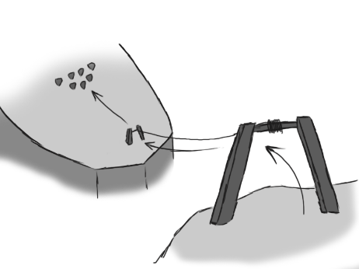

Figure 3 - Zipline Tutorial

**The Grapple-shot:**

As one of the more complex weapons, the grapple-shot would be demonstrated by a gap (that you can escape should you fail) that you must use the grapple special to cross. A respawning Lobuzz would be the enemy to grapple, so you can always cross the gap. Later areas can have the player chain multiple grapples together to cross the pits.

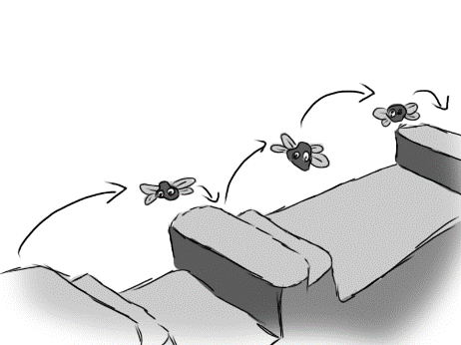

Figure - Grapple Tutorial

**The Daggers:**

Daggers, with their higher movement speed and smaller hitbox, make for a tricky weapon. The tutorial for this will include getting around enemies to reach a better attack position, and gaps which require the wall-running ability to cross.

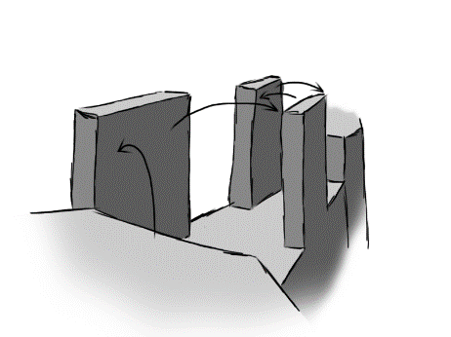

Figure 5 - Wall Running Tutorial

**The Staff:**

The staff would be the last unlock, as the twirl glide could make earlier levels too easy. Starting off by forcing the player to reflect projectiles back at unsuspecting enemies to open the way forward, the player would be given a large abyss with the goal on a floating island.

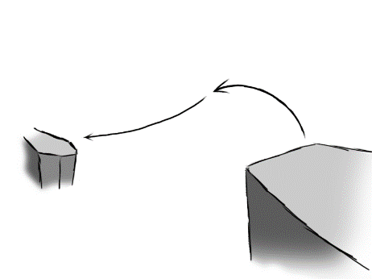

Figure 6 - Hover Tutorial